Problem

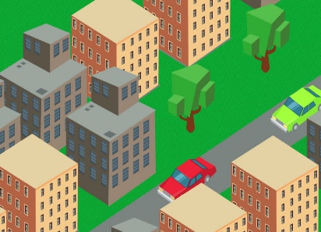  

Where do I start collecting garbage?

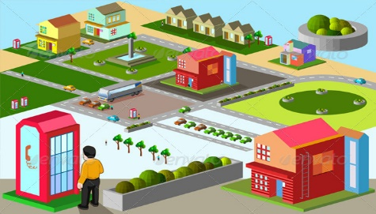

Solution

Sensor implemented dustbins in cities

 

Sensor implemented dustbins in cities



Easy and efficient waste collection with the help of sensors in dustbins which can detect filling up of dustbins.

Sensor notifies Waste Management Office when it’s time to collect the waste.

Sensor implemented dustbins in cities

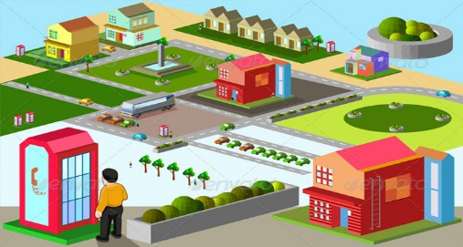

Product

